**AI PLAYGROUND**

T.E. mini-project report submitted in partial fulfilment of the requirements

of the degree of

**BACHELOR OF ENGINEERING IN ARTIFICIAL**

**INTELLIGENCE AND MACHINE LEARNING**

by

**Mr. Jatin Singh (251)**

**Mr. Madhavendra Singh (252)**

**Mr. Rudra Trivedi (266)**

Under the guidance of

**Mrs. Silviya D’monte**

**Department of Artificial Intelligence and**

**Machine Learning**

**VIDYA VIKAS EDUCATION TRUST’S**

**UNIVERSAL COLLEGE OF ENGINEERING**

**KAMAN, VASAI - 401208**

**UNIVERSITY OF MUMBAI**

**2022-2023**

**Vidya Vikas Education Trust’s**

**Universal College of Engineering, Vasai (E)**

**Department of AIML**



**CERTIFICATE**

This is to certify that, the Mini Project: 2B entitled “AI Playground” is the bonafide work of **Mr. Jatin Singh (251), Mr. Madhavendra Singh (252) and Mr. Rudra Trivedi (266)** submitted to the University of Mumbai in fulfilment of the requirement for the Mini Project: 2B Semester VI project work of T.E. AIML at Universal College of Engineering, Vasai, Mumbai at the Department of Artificial Intelligence and Machine Learning, in the academic year 2022-2023, Semester – VI.

Mrs. Silviya D’monte

**Supervisor**

Mr. John Kenny Dr. J.B. Patil

**Head of Department Principal**

**T.E. Mini Project-2B Report Approval**

This project report entitled “AI Playground” by of Mr. Jatin Singh, Mr. Madhavendra Singh and Mr. Rudra Trivediis approved for the Mini Project-2B Semester VI project work of T.E AIML at Universal College of Engineering, Vasai, in the academic year 2022-2023.

**Internal Examiner External Examiner**

**--------------------------------------------- ---------------------------------------------**

Date:

**Declaration**

I declare that this written submission represents my ideas in my own words and where other’s ideas or words have been included, I have adequately cited and referenced the original sources. I also declare that I have adhered to all principles of academic honesty and integrity and have not misrepresented or fabricated or falsified any idea/data/fact/source in my submission. I understand that any violation of the above will be cause for disciplinary action by the Institute and can also evoke penal action from the sources which have thus not been properly cited or from whom proper permission has not been taken when needed.

--------------------------------------

Signature

**Mr. Jatin Singh (251)**

--------------------------------------

Signature

**Mr. Madhavendra Singh (252)**

--------------------------------------

Signature

**Mr. Rudra Trivedi (266)**

Date:

Place:

**Abstract**

Nowadays everything is on the web. This is the only platform where you can avail many things for free. So, when it comes to education, why to lack there behind? Artificial Intelligence is a boon to the technology of the modernized technical era. But many AI aspirants face the problem of understanding the Algorithms. That’s why we have presented the idea of an AI Playground. AI Playground will be a application through which users can perform various Artificial Intelligence algorithms as well as basic Algorithms which will help students get a better understanding of how the algorithms work. In AI Playground, the user will be able to input the values to run the required algorithm. The main focus of our project is to help our teachers and students to make them better understand the use and techniques of the algorithms which they will be using further for projects and in many other regions. Our motivation is to make these algorithms easy to understand so that learners can master their foundations in order to excel in their careers. With the help of our app, students can self -learn through E-learning and understand the Algorithms according to their own pace and also visualize them. In days like today time is also an important factor and we can’t spend our whole day just to understand one single thing. Competition is increasing day-by-day so our platform can make you understand the algorithms in a very efficient and time-saving manner.

KEYWORDS – AI Playground, Time-saving, Application, Algorithms, Self-learn, Visualize, Efficient, E-learning.

**Contents**

Abstract 5

List of figures 8

List of tables 10

List of Symbols 11

List of abbreviations 12

**1 INTRODUCTION 1**  ii1.1 Project Overview

**2 REVIEW OF LITERATURE 3**

2.1 Existing System

2.2 Literature Survey

2.3 Problem Statement and Objective

**3 PROPOSED SYSTEM 12**

3.1 Achitecture / Framework

3.2 Algorithm

3.3 System Requirements

3.4 Fundamental Model

3.4.1 Data Flow Diagram

3.5 Unified Modelling Language Diagram

3.5.1 Use Case

3.5.2 Process Flow

**4 RESULT 28 iii**4.1 Proposed System

**4.2 Results**

**Conclusion 47**

**Appendix 48**

**References 50**

**Acknowledgement 37**

**List of Figures**

**Sr.No Name Page No**

2.1 **System workflow 15**

3.1 System Architecture 24

3.2 Linear Search Algorithm 25

3.3 Binary Search Algorithm 26

3.4 Selection Search Algorithm 26

3.5 Insertion Sort Algorithm 27

3.6 Bubble Sort Algorithm 28

3.7 Merge Sort Algorithm 29

3.8 Quick Sort Algorithm 30

3.9 Heap Sort Algorithm 31

3.10 Sudoku Backtracking Algorithm 32

3.11 N-Queen Problem 33

3.12 Knight’s tour 34

3.13 System Requirements 35

3.14 Use Case Diagram 37

3.15 Process Flow Diagram 38

3.16 Data Flow Diagram 39

4.1 Main GUI 41

4.2 Select Algorithm Type 42

4.3 Select Algorithm for Searching 42

4.4 Select Algorithm for Sorting 43

4.5 Select Algorithm(Backtracking) 43

4.6 General UI 44

4.7 General UI(Solution) 44

4.8 Customized UI for Sorting 45

4.9 Customized UI(Solution) 45

4.10 Solution of N-queen 46

**List of Tables**

**Sr.No Name Page No**

2.1 Literature Survey Table 17

**List of Symbols**

( Round open Bracket

) Round closed Bracket

[ Square open Bracket

] Square closed Bracket

- Subtraction

+ Addition

/ Division

: Colon

= Equal

" Double inverted comma

' Single inverted comma

× Multiplication

% Percentage

**List of Abbreviations**

AI Artificial Intelligence

App Application

Algo Algorithm

www World Wide Web

IDE Integrated Development Environment

E-leaning Electronic learning

M-learning Mobile learning

PC Personal Computer

HTML HyperText Markup Language

XML Extensible Markup Language

CSS Cascading Style Sheet

JS JavaScript

SVG Scalable Vector Graphics

Py Python

**Chapter 1**

**Introduction**

The physical classroom learning nowadays is no longer applicable for the current younger generations. Internet and distance learning which is generally known as online education plays a vital role in the country’s education system. It is undeniable that online education provides ample of benefits to young learners. Nevertheless, there are also many negative implications from online education. Also, as the Technology has drastically improved the existing educational system over the past fifteen years. ‘Self-learning,’ using online platforms, has replaced the traditional role learning. The umbrella of technology-based educational system incorporates multitudes of learning apps.

**1.1. Introduction**

We have learnt sorting algorithms like bubble sort, selection sort, insertion sort, quick sort. But often we fail to understand the core idea of a particular algorithm, maybe because we are unable to visualize how they work. So the most important thing to understand about these algorithms I visualization.

That’s why we are making this project to let everyone understand how these algorithms work and through this project you also will get a dee understanding of such sorting algorithms.

AI Playground will guide you step by step to complete this project and at the end of this project you will have an immense grip on some core concepts of Python as well. Adding this project on your resume will showcase your skills and add a great value to your profile.

This project is a good start for beginners and a refresher for professionals who have dabbled in data structures and algorithms using Python before and also web developers. The methodology can be applied to showcase any algorithm of one's choosing, so feel free to innovate!

**Chapter 2**

**Literature Survey**

A literature survey was carried out to find various papers published in international journals such as ICCES etc. related Sorting Visualizer. Online sorting platforms, E-learning platforms.

**2.1 Survey of Existing System**

Web based learning is an interaction on the World Wide Web which can run on any devices you want pc/laptops/mobile/tablets etc. that can be accessed anywhere and has capability of an excellent searching system, rich interaction and full support towards an effective learning and performance-based assessment. In addition, it has a characteristic of not being dependent on time and space. There are no minimum requirements of device specifications because it's a web application. According to survey visualgo.net , sortvisualizer.com, clementmihailescu.github.io, etc. We have found that all the existing web app do not provide advanced algorithm visualizers. Some of the web app only provide limited handling to the users like the only have to work with specific inputs and you cannot use you own inputs. The advantages and disadvantages have also been analyzed during this survey which I available in [2.2] .

The system workflow of the proposed system is shown as the user starts the app. The system works on the principle as shown in the Figure 2.1 . It shows how the Visualizer works with the data entered or pre-written in the system and it is analyzed and then return the output that you desire This AI Playground is used for visualization and more clear understanding of how the algorithm works for all students and teachers. Which will help them in their studies and teaching purposes

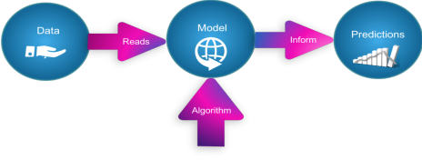

**Figure 2.1: System workflow**

**2.2 Literature Survey**

Table 2.1 shows the Literature Survey completed for the Mini Project work We have referred 3 journal/conference papers and studied the existing system to identify research gaps in their work to enhance the proposed system.

**Table 2.1 Literature Survey Table:**

|  |  |  |  |  |
| --- | --- | --- | --- | --- |
| Name of the Paper | Author and year of Publication | Publication Department | Advantages | Disadvantages |
| Visualizations of Sorting Algorithms | Mykhailo  Klunko  2019 | Department  of Computer Science,  Faculty of Science,  Palacky  University  Olomouc | Better algorithm understanding.  Varieties of algorithms included.  Application based.  No downloads   required | Less Downloads.  Requirement of Java.  Cannot be accessed through mobile phones. |
| Algorithm  Visualizer | Barnani  Goswami,  Anushka  Dhar,  Akash  Gupta,  Antriksh  Gupta  2021 | Department  of Computer Science and Engineering. | Better algorithm understanding.  Application based.  No internet  required | Not Online.  Updates needed  repetitively.  Less Users |
| The  Development of System for Algorithms,  Visualization using SimJava | Jamil  Abedalrahi m,  Jamil  Alsayaydeh, Azwan  Aziz,  Maslan  Zainon,  Oliinyk  2020 | ARPN  Journal of Engineering and Applied Sciences | Good Algorithm Understanding  Application based  No internet required | Not Web Based  Less Users  Updating Software repetitively. |

**2.2.1 Research Paper 1**

**#Details:**

Author: Mykhailo Klunko

Title: Visualization of Sorting Algorithms

Thesis type: bachelor thesis

Department: Department of Computer Science, Faculty of Science,

Palacký University Olomouc

Year of defense: 2019

Study field: Computer Science, full-time form

Thesis language: English

**#Abstract:**

The main goal of the thesis was to create a teaching support software with visualization of the most known sorting algorithms and their variations. The application supports a graphic visualization on selected algorithms on randomly generated or manually created array step-by-step execution possibility, pseudocode and current state of variables.

**#Advantages:**

● Better Algorithm Understanding.

● Varieties of Algorithm Included.

● Application Based

● No Internet Required

**#Disadvantages:**

● Less Downloads as Online Users need a web based application.

● Requirement of Java existing System in Users Device.

● Cannot be accessed through mobile phones as it is an Desktop Software.

**2.2.2 Research Paper 2**

**#Details:**

Author: Barnini Goswami , Anushka Dhar, Akash Gupta, Antriksh Gupta

Title: ALGORITHM VISUALIZER

Department: Department of Computer Science and Engineering

Research paper language: English

Year of publication:- 2021

**#Abstract:**

Over the years we've observed that algorithms, even though being a complex subject, are the foundation of computational thinking and programming skills of a student. So to ease up the hardships of students this idea of the project was formed. Our application Algorithm Visualizer is both interactive and alluring to students. It gives the students hands-on experience of the algorithms' implementation. It feeds into their imagination to help them get a better understanding while also helping teachers to help make their students understand better.

**#Advantages:**

● Better Algorithm Understanding.

● Application Based.

● No Internet Required.

**#Disadvantages:**

● Not Online.

● Need to update Application repetitively.

● Less Users.

**2.2.3 Research Paper 3**

**#Details:**

Author:- Jamil Abedalrahim Jamil Alsayaydeh, Maslan Zainon, A.

Oliinyk, Azwan Aziz, A. I. A. Rahman and Zikri Abadi Baharudin.

Title:- THE DEVELOPMENT OF SYSTEM FOR ALGORITHMS,

VISUALIZATION USING SIMJAVA.

Department:- ARPN Journal of Engineering and Applied Sciences

Research paper language: English

Year of publication:- 2020

**#Abstract:**

Algorithm visualization which is a form of high-level dynamic visualization of software that uses user interface techniques to portray and monitor the computational steps of algorithms. Moreover, algorithm visualization systems are also useful tools in algorithm engineering, particularly at several stages during the design, implementation, analysis, tuning, experimental evaluation, and presentation of the algorithms process. Algorithms are a captivating use case for visualization.

**#Advantages:**

● Better Algorithm Understanding.

● Application Based.

● No Internet Required.

**#Disadvantages:**

● Not Web based.

● Less Users.

● Updating software repetitively

**2.3. Problem Statement and Objectives**

To solve the problem of difficulty in understanding complex and lengthy algorithms, AI Playground is developed to visualize algorithms in an easy to understand manner. It is a web application that will help learners to understand algorithms quickly. Most of the algorithm visualizers are application based. To solve that, our team has developed a web based application which will allow all users to use the platform without downloading any software.

**# OBJECTIVES :**

● To make algorithms easy to understand.

● To visualize algorithms.

● To give teachers a platform to teach.

● To give students a platform to learn.

● Everyone can learn through our web based platform.

● To analyze complex and lengthy algorithms easily.

● To help students master their algorithmic foundations.

**2.4. Motivation**

Education in this modern world has changed a lot. From studying through ten’s of books to studying from all in one pdf, technology has come a long way. From scratching chalks on the boards to teaching using presentations, teachers and students have got all these platforms as a blessing, solving so many issues and helping teachers teach easily and students learn effectively. Usually Algorithms are Complex and hard to understand at very single line of code. Each iteration is performed by assessing different conditions programmed in a loop. Teaching and learning these in a step by step manner is not easy. Students need something to visualize in order to learn something complex. To help with this our team has come up with a new platform known as “AI Playground”. AI Playground gives opportunity to teachers and students to show the algorithm in a way that visualizes every step of the algorithm. Our motivation is to make these algorithms easy to understand so that learners can master their foundations in order to excel in their careers. Our platform can make you understand the algorithms in a very efficient and time-saving manner.

**Chapter 3**

**Proposed System**

This chapter includes a brief description of the proposed system and explores the different sections involved through which this system can be understood and represented.

**3.1 Architecture / Framework**

The AI Playground works in a very systematic way. From the Home Page of AI Playground, users can select the type of algorithm they want to run. After choosing the algorithm, users can customize the sorting speed of the algorithm. Users can also generate by inputting the Array Size or Min Value and Max Value. After customizing the algorithm, users can run the algorithm by clicking on “Start Sorting Algorithm” and in a few moments users will be able to visualize how the algorithm would run. Here is the diagrammatic representation of how AI Playground will work:

Figure 3.1 Architecture of AI-Playground

**3.2 Algorithm**

**Linear Search :**

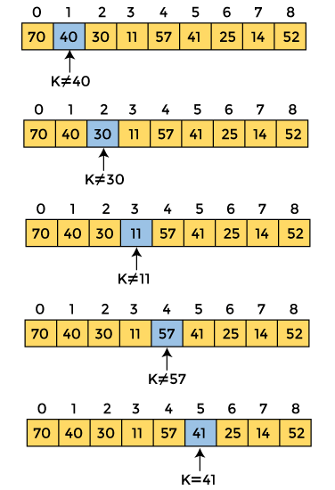

Figure 3.2 Linear Search Algorithm

**Binary Search :**

Figure 3.3 Binary Search Algorithm

**Selection Search :**

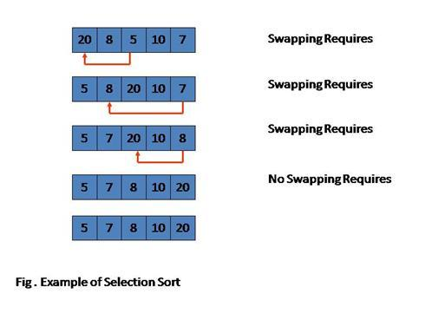

Figure 3.4 Selection Search Algorithm

**Insertion Sort :**

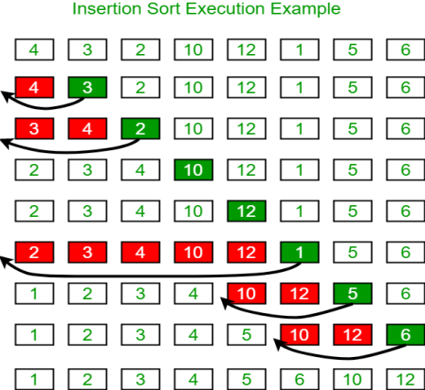

Figure 3.5 Insertion Sort Algorithm

**Bubble Sort :**

Figure 3.6 Bubble Sort Algorithm

**Merge Sort :**

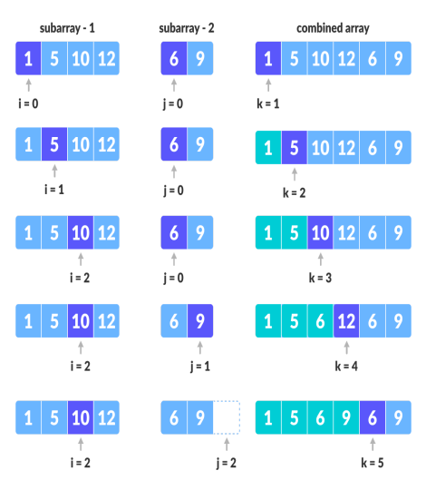

Figure 3.7 Merge Sort Algorithm

**Quick Sort :**

Figure 3.8 Quick Sort Algorithm

**Heap Sort :**

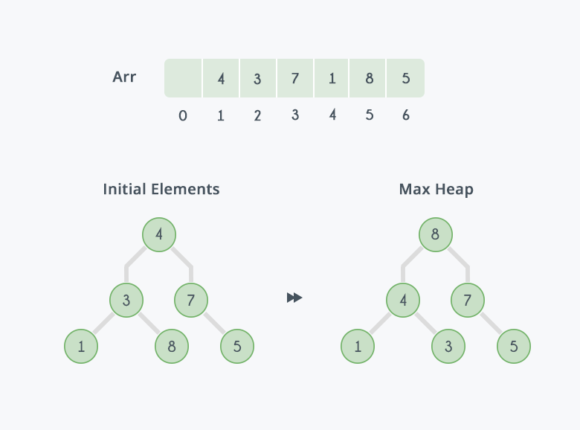

Figure 3.9 Heap Sort Algorithm

**Sudoku Backtracking Algorithm :**

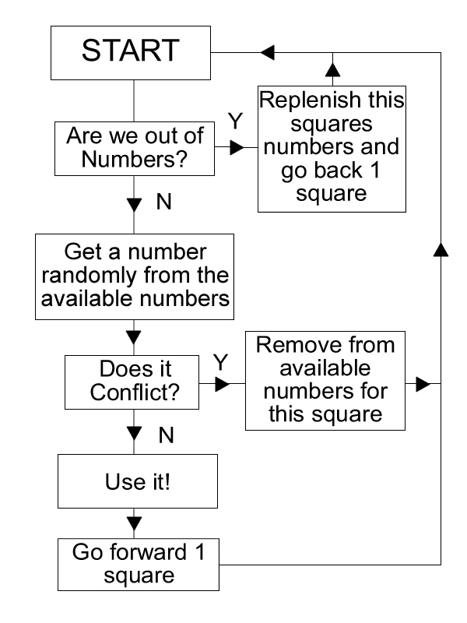

Figure 3.10 Sudoku Backtracking Algorithm

**N-Queen Algorithm:**

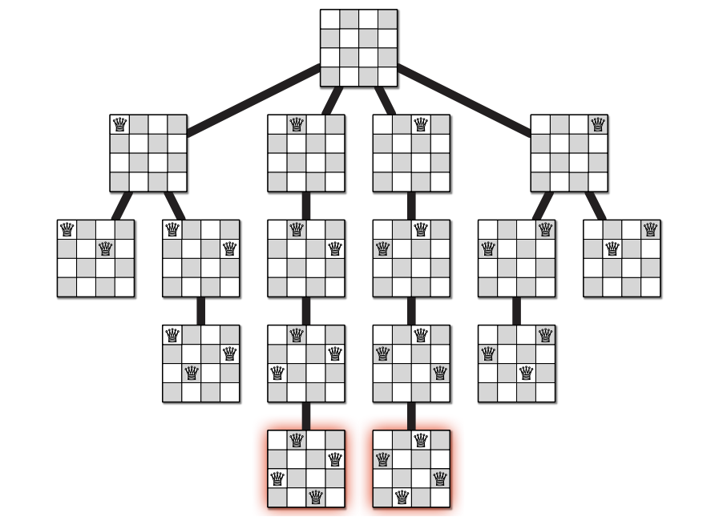

Figure 3.11 N-queen Algorithm

**Knights Tour :**

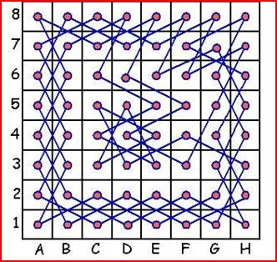

Figure 3.12 Knights Tour

**3.3 System Requirements(Hardware and Software)**

Here are the system requirements to use AI Playground:

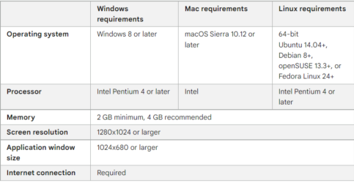Figure 3.13 System Requirements

**3.4 Fundamental Model**

**3.4.1 Data Flow Model**

Data Flow Diagram (DFD) shows graphical representation of the flow” of data through an information system, modelling its process aspects. It includes data inputs and outputs, data stores, and the various subprocesses the data moves through. DFDs are built using standardized symbols and notation to describe various entities and their relationships.

**3.5 Unified Modelling Language Diagram**

The Unified Modelling Language is a general-purpose, developmental, modelling language in the field of software engineering that is intended to provide a standard way to visualize the design of a system. We have prepared and designed the UML diagrams of – Use Case, Activity, Component, Deployment and Sequence Diagrams.

3.5.1 Use Case

Figure 3.5.1 denotes the Use Case Diagram of the proposed system. It shows the user’s interaction with the systems. The purpose of a use case diagram in Unified Modelling Language (UML) is to demonstrate the different ways that a user might interact with a system. In this use case diagram, there are three actors involved, the first actor is user, the second actor is police officer and the third actor is facial recognition system. It depicts the interactions between the various actors used in this system. All these interactions between actors and system is done in the Machine Learning environment.

Figure 3.14 Use Case

Figure 3.15 Process Flow

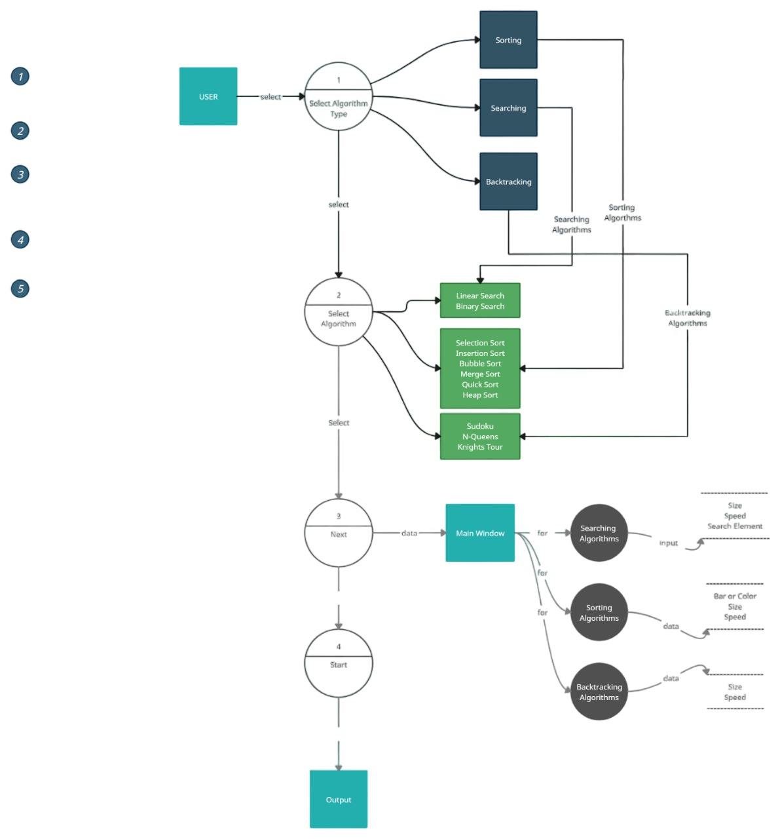

Figure 3.16 Data Flow Diagram

**Chapter 4**

**4.1 Proposed System**

Algorithms are usually very complex and difficult to understand. AI Playground gives users the platform to visualize the way algorithms work. Through this platform users can select an algorithm from plenty of available algorithms and see how they work visually. It helps the users to get the understanding of components and rules of each algorithm.

AI Playground gives the users the visual understanding of each iteration of the algorithm. AI Playground as a web based application will provide users such as teachers, students, interns, fresher programmers to understand and master these algorithmic foundations. In addition it doesn’t require any software to download. All web users can freely use this platform.

**4.2 Results**

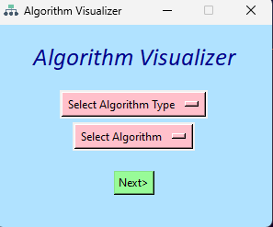

Figure 4.1 Main GUI

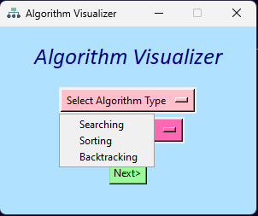

Figure 4.2 Select Algorithm Type

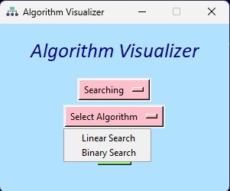

Figure 4.3 Select Algorithm for Searching

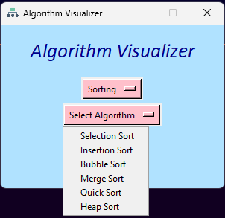

Figure 4.4 Select Algorithm for Sorting

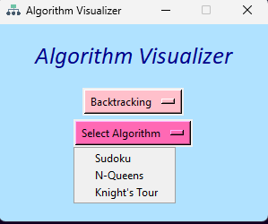

Figure 4.5 Select Algorithm for Backtracking

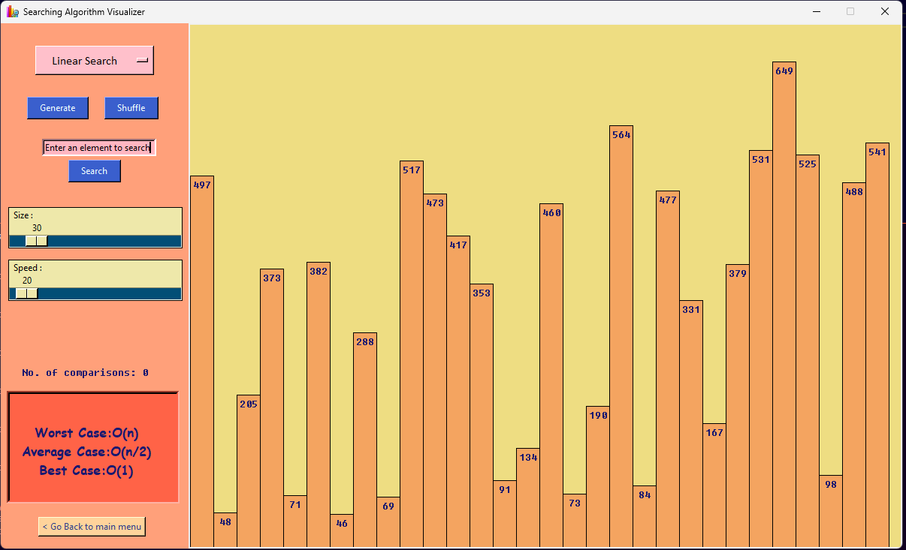

Figure 4.6 General UI

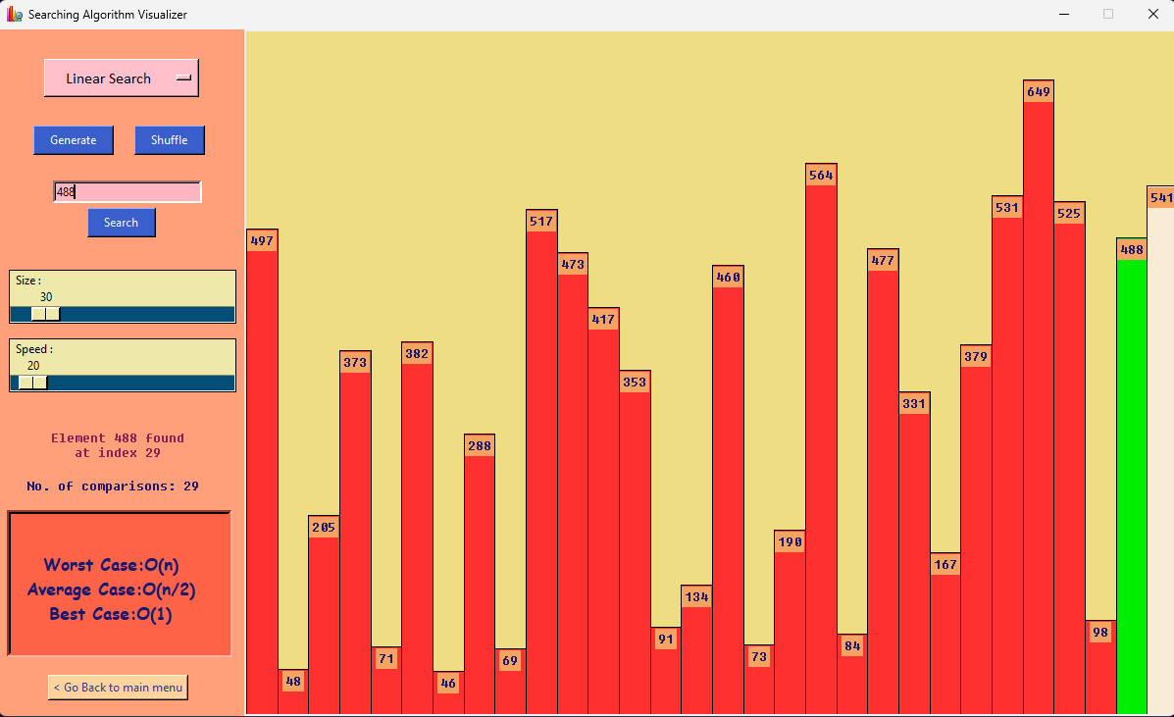

Figure 4.7 General UI (Solution)

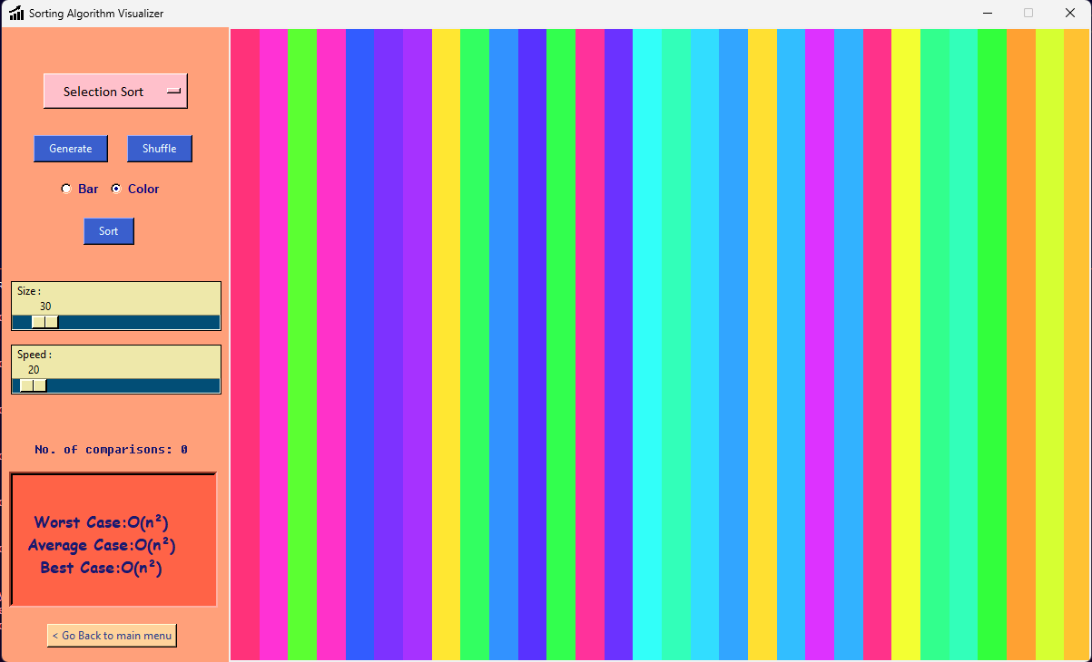

Figure 4.8 Customized UI for Sorting Algorithm’s

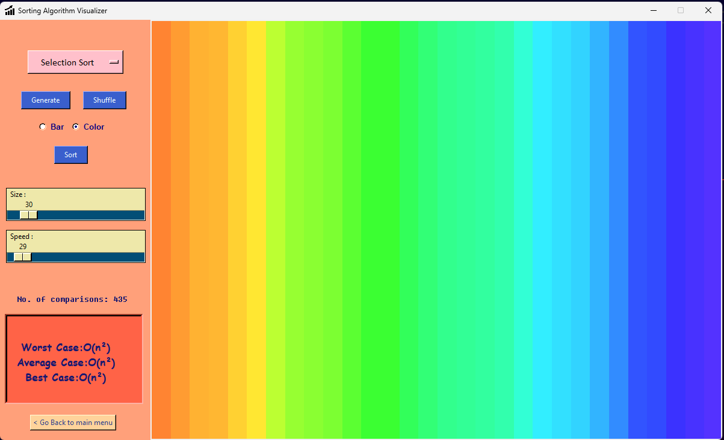

Figure 4.9 Customized UI Solution

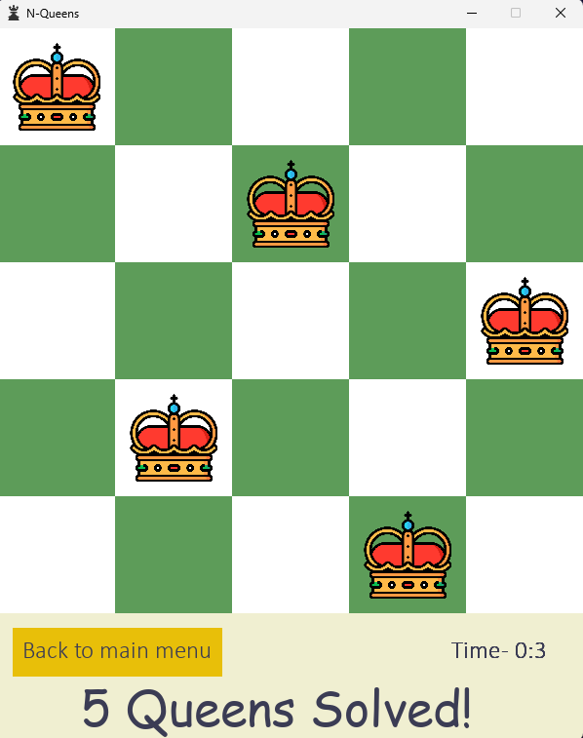

Figure 4.10 Solution of N-Queen

**Conclusion**

In conclusion, AI Playground will be very beneficial for both students as well as the educator, as learning and teaching algorithms will be like a cup of tea for students and teachers respectively. With the help of this students will not only understand algorithms properly but also learn time management. The proposed System is designed so that it will be accessible at any time anywhere it will also make understanding algorithms easier and faster.

**APPENDIX**

1. Python

Python is a high-level, general-purpose programming language. Its design philosophy emphasizes code readability with the use of significant indentation. Python is dynamically-typed and garbage-collected. It supports multiple programming paradigms, including structured (particularly procedural), object-oriented and functional programming. It is often described as a "batteries included" language due to its comprehensive standard library. Guido van Rossum began working on Python in the late 1980s as a successor to the ABC programming language and first released it in 1991 as Python 0.9.0. Python 2.0 was released in 2000 and introduced new features such as list comprehensions, cycle-detecting garbage collection, reference counting, and Unicode support. Python 3.0, released in 2008, was a major revision that is not completely backward-compatible with earlier versions. Python 2 was discontinued with version 2.7.18 in 2020. Python consistently ranks as one of the most popular programming languages

2. tkinter

The [tkinter](https://docs.python.org/3/library/tkinter.html" \l "module-tkinter" \o "tkinter: Interface to Tcl/Tk for graphical user interfaces) package (“Tk interface”) is the standard Python interface to the Tcl/Tk GUI toolkit. Both Tk and [tkinter](https://docs.python.org/3/library/tkinter.html" \l "module-tkinter" \o "tkinter: Interface to Tcl/Tk for graphical user interfaces) are available on most Unix platforms, including macOS, as well as on Windows systems.

Running python -m tkinter from the command line should open a window demonstrating a simple Tk interface, letting you know that [tkinter](https://docs.python.org/3/library/tkinter.html" \l "module-tkinter" \o "tkinter: Interface to Tcl/Tk for graphical user interfaces) is properly installed on your system, and also showing what version of Tcl/Tk is installed, so you can read the Tcl/Tk documentation specific to that version.

Tkinter supports a range of Tcl/Tk versions, built either with or without thread support. The official Python binary release bundles Tcl/Tk 8.6 threaded. See the source code for the _tkinter module for more information about supported versions.

Tkinter is not a thin wrapper, but adds a fair amount of its own logic to make the experience more pythonic. This documentation will concentrate on these additions and changes, and refer to the official Tcl/Tk documentation for details that are unchanged.

3. Pygame

First, Python is easy to learn and has a clean and human-readable language syntax. This makes it a perfect choice for beginners or experienced programmers who want quick results.

It’s very easy to install and start playing with. In addition, there is a set of modules specifically designed for game development - Pygame.

The speed is relatively good, but Python does not compete with C++ or C# in this area.

If you’re wondering whether you should even consider using Python, we'd say - IT DEPENDS.

Python is really great if:

* You want to learn the principles of game development fast.

4. VS code / Pycharm IDE

PyCharm IDE was used for setting up the entire project.

**References**

[1] T. Bingmann. “The Sound of Sorting - ‘Audibilization’ and Visualization of Sorting Algorithms.” Panthemanet Weblog. Impressum, 22 May 2013. Web. 29 Mar. 2017.

[2] http://panthema.net/2013/sound-of-sorting

[3] Bubble-sort with Hungarian (“Cs ́ang ́o”) Folk Dance. Dir. K ́atai Zolt ́an and T ́oth L ́aszl ́o. YouTube. Sapientia University, 29 Mar. 2011. Web. 29 Mar.2017.

[4] A. Kerren and J. T. Stasko. (2002) Chapter 1 Algorithm Animation. In: Diehl S.(eds) Software Visualization. Lecture Notes in Computer Science, vol 2269. Springer, Berlin, Heidelberg.

[5] A. Moreno, E. Sutinen, R. Bednarik, and N. Myller. Conflictive animations as engaging learning tools. Proceedings of the Koli Calling ’07 Proceedings of the Seventh Baltic Sea Conference on Computing Education Research - Volume 88, Koli ‘07 (Koli National Park, Finland), pages 203-206.

[6] J. Stasko. Using Student-built Algorithm Animations As Learning Aids. Proceedings of the Twentyeighth SIGCSE Technical Symposium on Computer Science Education. SIGCSE ‘97 (San Jose, California), pages 25-29. <http://doi.acm.org/10.1145/268084.268091>

**Acknowledgement**

We take this opportunity to express our deep sense of gratitude to our project guide and project coordinator guide **Mrs. Silviya D’monte**, for his continuous guidance and encouragement for our project work. It is because of her experience and wonderful knowledge. We would also like to thank **Mr. John Kenny**, Head of Artificial Intelligence and Machine Learning department for her encouragement, whole-hearted cooperation and support.

We would also like to thank our Principal **Dr. J. B. Patil** and the management of Universal College of Engineering, Vasai, Mumbai for providing us all the facilities and the work friendly environment. We acknowledge with thanks, the assistance provided by departmental staff, library and lab attendants.

**Mr. Jatin Singh (251)**

**Mr. Madhavendra Singh (252)**

**Mr. Rudra Trivedi(266)**